Count frequency of the Word
Views.py
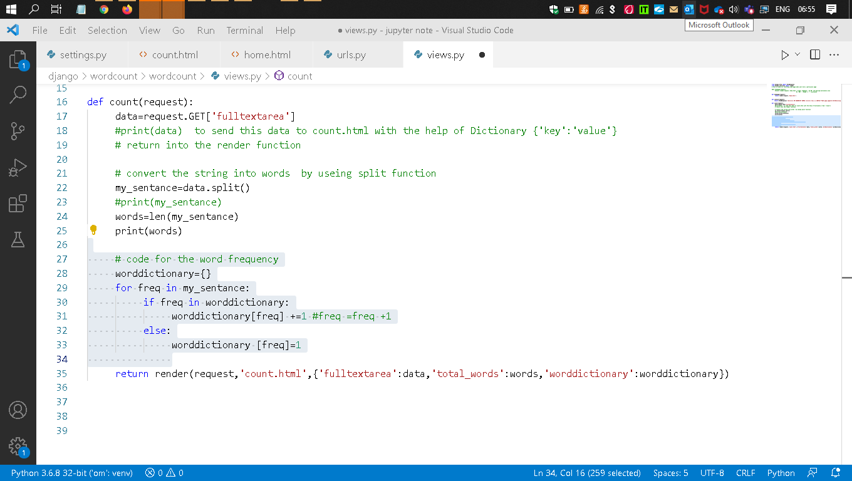
Count.html
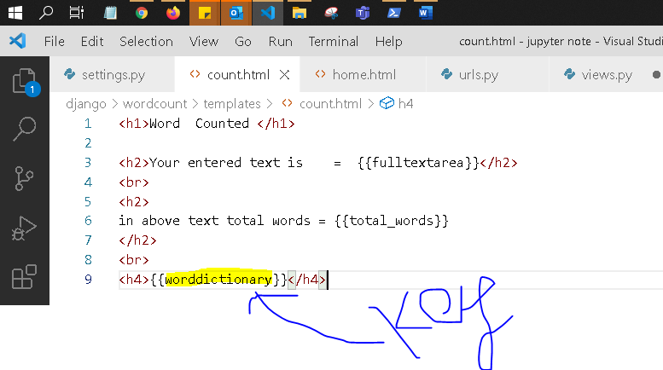

Re-run the server
Homepage (Login.html)
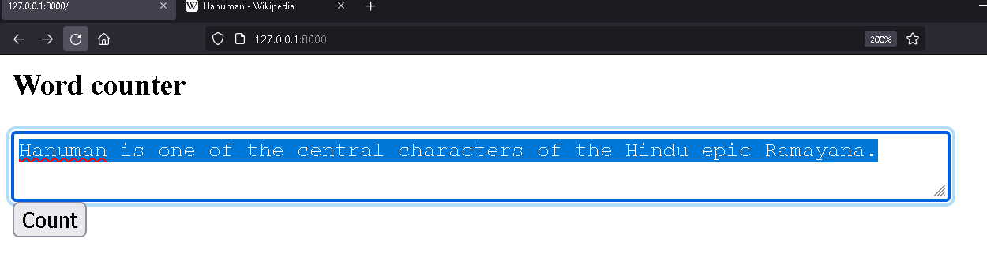
Count.html
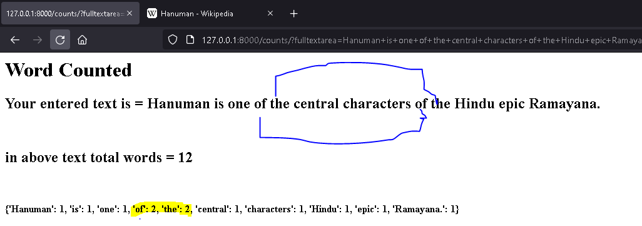

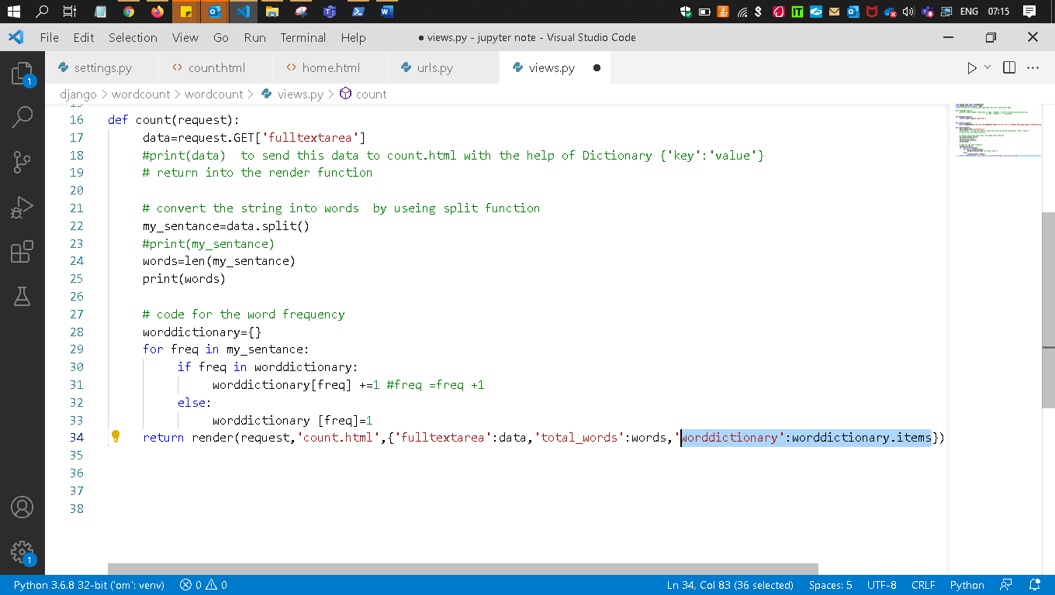
Q - Now make it in propper formate

From highlighted
worddictionary':worddictionary.items

worddictionary = key
worddictionary.items =value
this will give you all the items(key,value) pairs of the dictionary

Count.html
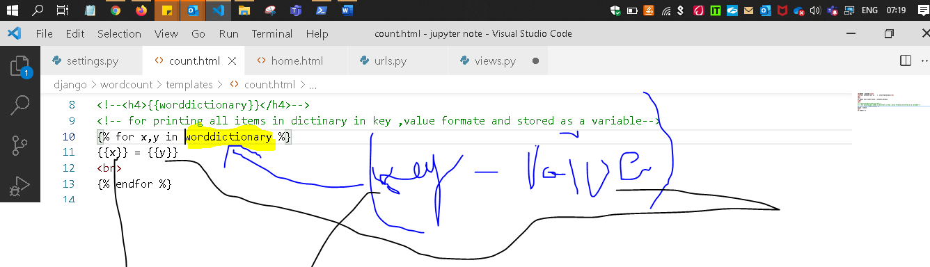
Save and Re- run the Server/refresh the count.html page
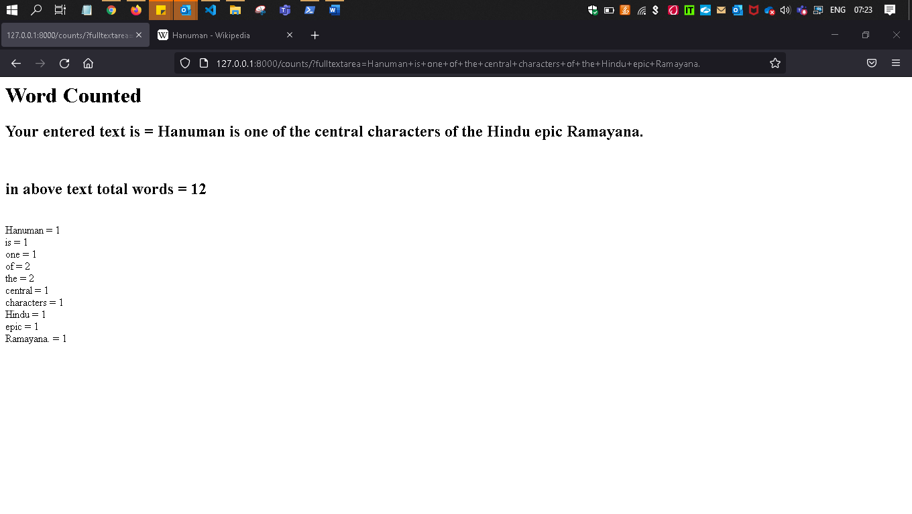
Now make all these in sorted form
Those who has greatest frequescey comes first -→then lesser-----→then lesser-----→then lesser----
Only change in views.py

How to Sort the Dictionary

The sorted() method along with Python operator.itemgetter() method can be used to sort a dictionary by value in Python.
Python operator module has various in-built functions to manipulate the data and values. The operator.itemgetter(m) method considers the input object as an iterable and fetches all the ‘m’ values from the iterable.

operator is a built-in module providing a set of convenient operators. In two words operator.itemgetter(n) constructs a callable that assumes an iterable object (e.g. list, tuple, set) as input, and fetches the n-th element out of it.

In the above function, we have set the parameter key = operator.itemgetter(1) because here ‘1’ represents the values of the dict, and ‘0’ represents the keys of the dict. Thus, we have sorted the dict by values in ascending order.

Syntax: Python sorted() method
sorted(iterable, key)
- iterable: It represents the elements to be sorted.
- key(optional): A function to decide the order of sorting the elements.
Example:
from operator import itemgetter
inp_dict = { 'a':3,'ab':2,'abc':1,'abcd':0 }
print("Dictionary: ", inp_dict)
sort_dict= dict(sorted(inp_dict.items(), key=operator.itemgetter(1)))
print("Sorted Dictionary by value: ", sort_dict)

In the above function, we have set the parameter key = operator.itemgetter(1) because here ‘1’ represents the values of the dict, and ‘0’ represents the keys of the dict. Thus, we have sorted the dict by values in ascending order.
Output- sorted in assending order by value
Dictionary: {'a': 3, 'ab': 2, 'abc': 1, 'abcd': 0}
Sorted Dictionary by value: {'abcd': 0, 'abc': 1, 'ab': 2, 'a': 3}

So we need to do same soarteing into our project
#Those who has greatest frequescey comes first -◊then lesser-----◊then lesser-----◊then lesser-sorted_list=sorted(worddictionary.items(), key=operator.itemgetter(1), reverse=True)
return render(request, 'count.html',{'fulltextarea':data,'total_words':words,'worddictionary':sorted_list})

sorted_list=sorted(worddictionary.items(),key=operator.itemgetter(1),reverse=True)

Explanation
sorted_list=sorted(worddictionary.items(), key=operator.itemgetter(1), reverse=True)

sorted(iterable, key)

sorted(worddictionary.items(), key=operator.itemgetter(1)
The sorted() method along with Python operator.itemgetter() method can be used to sort a dictionary by value in Python.

worddictionary. ---- our dictionary name
worddictionary.items(), -----
items() method returns a view object. Return the dictionary's key-value pairs: The view object contains the key-value pairs of the dictionary, as tuples in a list.
d={'one':1,'two':2,'Ten':10}
print('printing original dictionary ',d)
# printing original dictionary {'one': 1, 'two': 2, 'Ten': 10}
print(' **** items- ',d.items())
see below output it gives list[] as a itterable objects
# **** items- dict_items([('one', 1), ('two', 2), ('Ten', 10)])
w=d.items()
print('type of W = ',type(w))
#type of W = <class 'dict_items'>

sorted(iterable, key)

key=operator.itemgetter(1)
key = operator.itemgetter(1) because here ‘1’ represents the values of the dict, and ‘0’ represents the keys of the dict. Thus, we have sorted the dict by values in ascending order.
Hence gives in ascending order

operator is a class so we need to import that also
so
sorted(worddictionary.items(), key=operator.itemgetter(1)
by this line it is sorteing the dictionary’s value in assending order

sorted(worddictionary.items(), key=operator.itemgetter(1), reverse=True)----
now Soarteing the values in descending order because ,reverse=True also passed
assending -------------→ reversed()

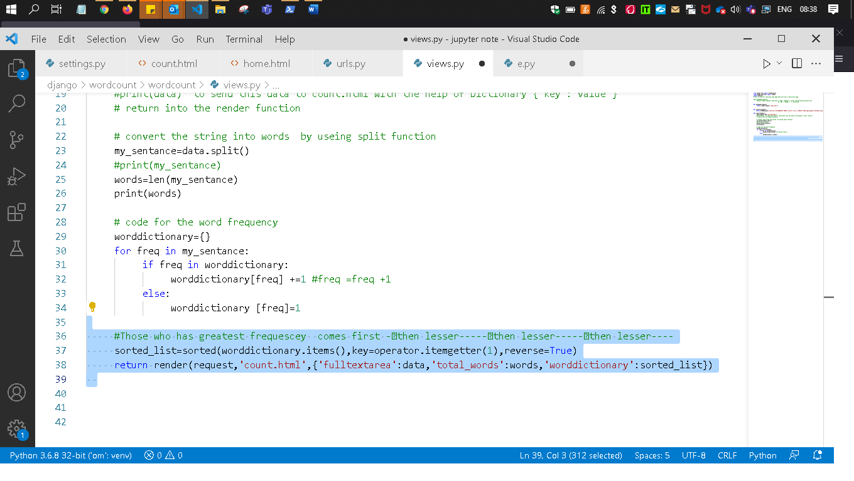
Save / refresh the page
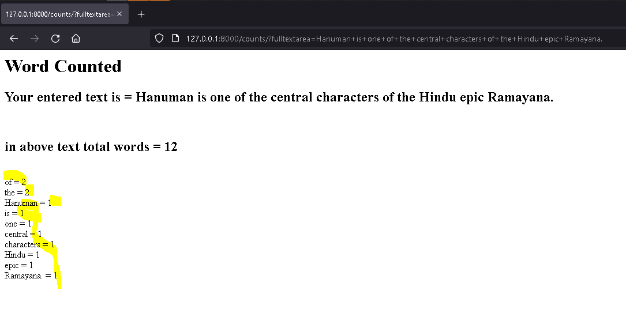
See the above all are sorted on the bases of values of the worddictionary (Dictionary)

